**SMART BORROWER AUTOMATION BOT**

# A PROJECT REPORT

Submitted by

**SURUTHI S (220701294)**

in partial fulfillment for the course

OAI1903 - INTRODUCTION TO ROBOTIC PROCESS AUTOMATION

In the modern financial sector, efficient borrower management is more critical than ever. Traditional methods of tracking repayments, calculating interests, and managing borrower data are time-consuming, repetitive, and prone to errors. The Smart Borrower Automation Bot addresses these challenges by leveraging RPA technology to automate key financial processes in lending institutions. From loan approvals to repayment tracking, the bot ensures seamless workflows, enhancing productivity and accuracy. for the degree of

**BACHELOR OF ENGINEERING**

**IN**

# **COMPUTER SCIENCE AND ENGINEERING**

**RAJALAKSHMI ENGINEERING COLL EGE**

**RAJALAKSHMI NAGAR**

**THANDALAM**

**CHENNAI – 602 105**

# NOVEMBER 2024

**RAJALAKSHMI ENGINEERING COLLEGE**

**CHENNAI - 602105**

**BONAFIDE CERTIFICATE**

Certified that this project report “**SMART BORROWING AUTOMATION BOT**” is the bonafide work of “**SURUTHI S (220701294)**” who carried out the project work for the subject OAI1903-Introduction to Robotic Process Automation under my supervision.

**Mrs. U.Farjana , M.Tech**

SUPERVISOR

Assistant Professor

Department of Computer Science and Engineering

Rajalakshmi Engineering College

Rajalakshmi Nagar

Thandalam

Chennai - 602105

Submitted to Project and Viva Voice Examination for the subject

OAI1903-Introduction to Robotic Process Automation held on .

# **ABSTRACT**

The Smart Borrower Automation Bot is an innovative Robotic Process Automation (RPA) solution designed to automate borrower data processing, loan approvals, and repayment tracking. This bot ensures accurate calculations of interest and automated repayment notifications, minimizing manual errors. By streamlining workflows, it optimizes efficiency, reduces costs, and enhances user satisfaction within lending institutions.

The Smart Borrower Automation Bot is an innovative robotic process automation (RPA) solution designed to automate the management and reconciliation of loan repayments or interest calculations within academic institutions. The bot streamlines the retrieval and validation of penalty data from institutional records, ensuring accuracy and compliance. By automating tasks such as matching loan repayments or interest calculations to payments, generating structured reports, and sending automated notifications, the system reduces manual effort and improves efficiency. Users can customize reconciliation rules and filters, enabling tailored workflows. With robust error handling and real-time updates, the bot ensures reliability, minimizes human error, and provides a scalable solution to simplify administrative processes in educational environments.

#### **ACKNOWLEDGEMENT**

Initially we thank the Almighty for being with us through every walk ofour life and showering his blessings through the endeavour to put forth this report. Our sincere thanks to our Chairman **Thiru. S.Meganathan, B.E., F.I.E.,** our Vice Chairman **Mr. M.Abhay Shankar, B.E., M.S.,** and our respected Chairperson **Dr. (Mrs.) Thangam Meganathan, M.A., M.Phil., Ph.D.,** for providing us with the requisite infrastructure and sincere endeavouring in educating us in their premier institution.

Our sincere thanks to **Dr. S.N.Murugesan, M.E., Ph.D.,** our beloved Principal for his kind support and facilities provided to complete our work in time. We express our sincere thanks to **Dr. P.Kumar, M.E., Ph.D.,** Professor and Head of the Department of Computer Science and Engineering for his guidance and encouragement throughout the project work. We convey our sincere and deepest gratitude to our internal guides, **Mrs. J. Jinu Sophia, M.E., (Ph.D.),** Assistant Professor (SG), Department of Computer Science and Engineering for their valuable guidance throughout the course of the project. We are very glad to thank our Project Coordinators, **Dr. N.Durai Murugan, M.E., Ph.D.,** Associate Professor, and**Mr. B.Bhuvaneswaran, M.E.,** Assistant Professor (SG), Department of Computer Science and Engineering for their useful tips during our review to build our project.

**SURUTHI S (220701294)**

# TABLE OF CONTENTS

**CHAPTER NO. TITLE PAGE NO.**

|  |  |
| --- | --- |
| **ABSTRACT** | iii |
| **LIST OF FIGURES** | **vi** |
| **1. INTRODUCTION** | **1** |
| 1.1 GENERAL | 1 |
| 1.2 EXISTING SYSTEM | 2 |
| 1.3 PROPOSED SYSTEM | 3 |
| **2. LITERATURE REVIEW** | **4** |
| 2.1 GENERAL | 4 |
| **3. SYSTEM DESIGN** | **6** |
| 3.1 SYSTEM FLOW DIAGRAM | 6 |
| 3.2 ARCHITECTURE DIAGRAM | 7 |
| 3.3 SEQUENCE DIAGRAM | 8 |
| **4. PROJECT DESCRIPTION** | **9** |
| 4.1 CREATING PROJECT | 9 |
| 4.2 PACKAGES REQUIRED | 9 |
| 4.3 PROJECT WORKFLOW | 10 |
| 4.3.1 ACTIVITIES USED | 10 |
| 4.3.2 EXPLAINING SEQUENCE | 11 |
| **5. OUTPUT SREENSHOTS** | **13** |
| **6. CONCLUSIONS** | **19** |
| **APPENDICES** | **20** |
| **REFERENCES** | **24** |

# LIST OF FIGURES

|  |  |  |
| --- | --- | --- |
| **Figure No** | **Figure Name** | **Page No** |
| 3.1 | System Flow Design | 6 |
| 3.2 | Architecture Diagram | 7 |
| 3.3 | Sequence Diagram | 8 |
| 4.3.2 | Sequence Creation | 11 |
| 5.1 | Source Input Box | 13 |
| 5.2 | Destination Input Box | 13 |
| 5.3 | Travel Date Input Box | 14 |
| 5.4 | Email Id Input Box | 14 |
| 5.5 | Source Selection | 15 |
| 5.6 | Destination Selection | 15 |
| 5.7 | Travel Date Selection | 16 |
| 5.8 | Data Extraction | 16 |
| 5.9 | Successful Email Delivery | 17 |
| 5.10 | Email Attachment | 17 |

# **CHAPTER 1**

# **INTRODUCTION**

# 1.1 GENERAL

# In the modern world, efficient management of lending institution resources is more important than ever. For academic institutions and libraries alike, the process of tracking borrowed books, managing loan repayments or interest calculations, and reconciling records can be time-consuming, repetitive, and prone to human error. Whether it’s for managing individual user accounts or overseeing an entire lending institution system, administrators often face the tedious task of manually reviewing borrowing records, calculating overdue loan repayments or interest calculations, and ensuring accurate updates to lending institution databases. This labour-intensive process can be overwhelming, especially for libraries with high user traffic or extensive collections. Furthermore, there’s the risk of inconsistencies in record management or delays in penalty reconciliation, leading to inefficiencies and user dissatisfaction.

# To address these challenges, the Smart Borrower Automation Bot offers an innovative solution that leverages Robotic Process Automation (RPA) to simplify and optimize lending institution management processes. By automating the tasks of tracking overdue books, calculating fines, and reconciling loan repayments or interest calculations, the bot significantly reduces the workload for lending institution staff while improving accuracy and efficiency. Users simply input key details such as user IDs, book return dates, and borrowing history, and the bot retrieves and processes all relevant data from lending institution systems. It then organizes this information into a structured report or database entry, providing administrators with comprehensive insights at a glance.

# Moreover, the Smart Borrower Automation Bot offers additional features such as customizable rules for fine calculation, automatic notifications to users regarding overdue loan repayments or interest calculations, and real-time updates to lending institution records. Once the reconciliation process is complete, the bot can generate and send summary reports to administrators or users, ensuring transparency and convenience without the need for manual follow-ups or checks.

# This automation provides numerous benefits. It streamlines lending institution management processes, saving administrators valuable time while ensuring that records are accurate, up-to-date, and organized. By reducing the potential for human error, the bot ensures that fines and loan repayments or interest calculations are calculated fairly and consistently, fostering trust and efficiency in lending institution operations. Whether for individual lending institution branches or larger academic institutions, the Smart Borrower Automation Bot offers a powerful, scalable, and user-friendly tool that makes lending institution management more efficient, less stressful, and more accurate.

# 1.2 EXISTING SYSTEM

The current process for managing lending institution resources, including tracking borrowed books and reconciling loan repayments or interest calculations, is highly manual and labour-intensive. Library staff must review borrowing records, calculate overdue fines, and update databases manually, which involves repetitive tasks prone to errors and delays. Notifications to users about overdue loan repayments or interest calculations or book returns are often handled separately, leading to inconsistencies and miscommunication. Additionally, this system lacks automation, requiring frequent checks and updates to ensure records are accurate and loan repayments or interest calculations are applied correctly.

# 1.3 PROPOSED SYSTEM

The Smart Borrower Automation Bot provides an automated and efficient solution to address these challenges. The bot automates the process of tracking borrowed books, calculating overdue loan repayments or interest calculations, and reconciling records. It retrieves user input such as book details, return dates, and borrowing history, processes the data, and organizes it into structured reports. Customizable features like fine calculation rules and automated user notifications ensure tailored and accurate management. The reconciled data and notifications are updated in real-time and sent to users or administrators, eliminating the need for manual tracking. This solution saves time, reduces errors, and enhances the efficiency of lending institution operations, making resource management seamless for institutions.

**CHAPTER 2**

**LITERATURE REVIEW**

# 2.1 GENERAL

In recent years, automation has transformed how administrative tasks are managed, particularly in environments that rely heavily on repetitive processes like lending institution resource management. Robotic Process Automation (RPA) has emerged as a powerful tool to enhance efficiency, reduce errors, and streamline workflows. By mimicking human actions such as data collection, validation, and organization, RPA tools like UiPath and Automation Anywhere have been widely adopted across sectors including education, healthcare, and logistics. These tools automate tedious tasks, enabling institutions to focus on higher-value activities while maintaining accuracy and compliance.

In the context of lending institution management, automation has proven especially useful for handling tasks such as tracking borrowed books, reconciling overdue loan repayments or interest calculations, and notifying users. For example, a study by Johnson and Patel (2017) demonstrated the advantages of using automation to manage lending institution fines and improve communication with users. Their system automated overdue notifications but lacked real-time reconciliation and error handling, key features addressed by the Smart Borrower Automation Bot. Similarly, Kumar et al. (2019) explored the use of automation in lending institution inventory management, highlighting its potential to reduce administrative overhead and improve record accuracy. However, their approach did not include fine calculation or user-specific customization, areas where the Smart Borrower Automation Bot excels.

Further advancements in lending institution automation have leveraged data processing and notification systems to enhance user engagement. For instance, Chen and Wang (2020) proposed a system that tracks user borrowing history and generates automated reminders for book returns. While effective, it did not include a robust penalty reconciliation mechanism or support for scalable report generation. Another study by Lee et al. (2021) emphasized the importance of integrating real-time updates and customizable rules into lending institution management systems, particularly for handling high user traffic. These features are integral to the Smart Borrower Automation Bot, which allows administrators to define fine calculation rules, automate record updates, and generate detailed reports tailored to institutional needs.

Overall, while several systems have explored automation in lending institution management, many fail to provide a comprehensive solution that integrates fine reconciliation, user notifications, real-time updates, and tailored reporting. The Smart Borrower Automation Bot bridges this gap by combining RPA technology, data validation, customizable workflows, and automated reporting to create a scalable and user-friendly solution for efficient lending institution resource management.

**CHAPTER 3**

**SYSTEM DESIGN**

# 3.1 SYSTEM FLOW DESIGN

A flowchart is a type of diagram that represents an algorithm, workflow or process. The flowchart shows the steps as boxes of various kinds, and their order by connecting the boxes with arrows. This diagrammatic representation illustrates a solution model to a given problem.

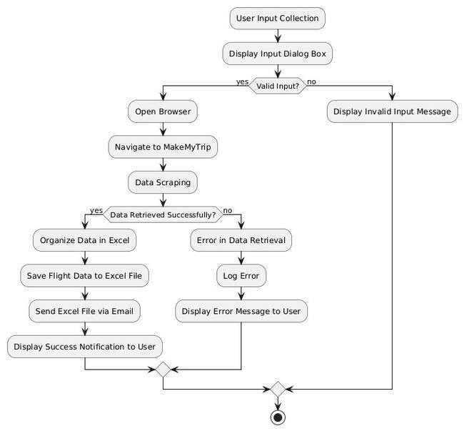

Fig 3.1 System Flow Design

# 3.2 ARCHITECTURE DIAGRAM

An Architecture Diagram for the Smart Borrower Automation Bot visually represents the system's components and their interactions. It highlights the user input layer, data processing and reconciliation, storage, and notification layers, showcasing how borrowing records are retrieved, loan repayments or interest calculations are calculated, organized in Excel, and sent via email. This diagram provides a clear understanding of the overall system design and flow, helping stakeholders see how each component contributes to automating lending institution resource management efficiently

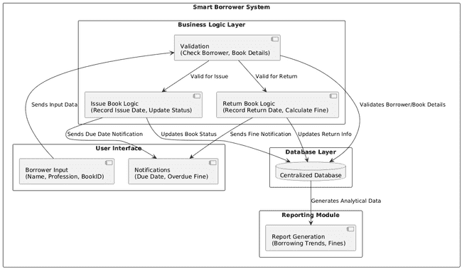 .

Fig 3.2 Architecture Diagram

# 3.3 SEQUENCE DIAGRAM

A sequence diagram is a type of interaction diagram that describes how—and in what order—a group of objects works together in the Smart Borrower Automation Bot. It is a type of UML (Unified Modeling Language) diagram that illustrates the interactions and messages exchanged between various components or objects in the lending institution management system over time. In the context of this project, the sequence diagram provides a dynamic view of how the bot interacts with input sources (e.g., borrowing records), processes data (e.g., fine reconciliation), and communicates with users (e.g., sending notifications). It highlights the flow of operations, focusing on the order of interactions between components like the user, database, bot workflows, and email services.

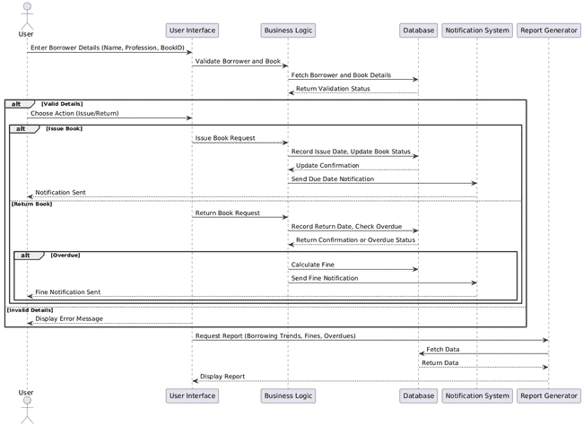

Fig 3.2 Sequence Diagram

**CHAPTER 4**

**PROJECT DESRIPTION**

# 4.1 CREATING PROJECT

Open UiPath Studio and check the version of the application. While it’s not mandatory to use the latest version, it is recommended as updates may include new features or improvements to existing Packages/Activities/Properties that could enhance the project. Once the application is opened, create a new process, name the file appropriately (e.g., Smart Borrower Automation Bot), and choose the directory where the UiPath files will be stored. After completing these steps, you will be ready to proceed with building the workflows for automating lending institution resource management and penalty reconciliation.

# 4.2 PACKAGES REQUIRED

For the successful completion of the Smart Borrower Automation Bot, it is crucial to download the necessary packages to enable the required activities. The following packages should be installed:

* **UiPath.Excel.Activities**: To manage Excel files for organizing borrowing records and penalty details.
* **UiPath.Mail.Activities**: For sending penalty reports and notifications via email to users and administrators.
* UiPath.WebAPI.Activities: For integrating external APIs, if needed, to enhance lending institution management workflows.
* UiPath.UIAutomation.Activities: For interacting with lending institution management systems, extracting user and book details.
* **UiPath.System.Activities**: For performing essential workflow automation tasks like logging, decision-making, and exception handling.

# 4.3 PROJECT WORKFLOW

Now, as we know the objective of the project it is time to create the workflow that actually makes up the project. The workflow for this project is simple.

4.3.1 ACTIVITES USED

To create the project the following activities are required:

## • **Input Dialog** – To capture user inputs such as user ID or return dates.

## • **Invoke Workflow** – To call reusable workflows for specific tasks like fine calculation or report generation.

## • **Try Catch** – To handle errors and ensure smooth execution of the bot.

## • Read Range – To read lending institution records from Excel files or databases.

## • **Write Range** – To update or organize reconciled data into structured Excel files.

## • **Send SMTP Mail Messages** – To send penalty notifications and summary reports via email.

## • **Log Message** – To log the execution details and track the bot’s performance.

## • **Filter Data Table** – To apply rules for fine calculation and customize the reconciliation process.

## • **Message Box** – To provide real-time updates or prompts for user interaction.

## • **Kill Process** – To ensure the termination of unused processes during execution.

## 

## 

## 

4.3.2.EXPLAINING SEQUENCE

Here’s the sequence of the Smart Borrower Automation Bot project, detailing each step in the workflow from start to finish:

1. **User Input Collection:**  
   The bot prompts the administrator to input essential information such as user ID, book return dates, or penalty rules using an Input Dialog activity.  
   This ensures the bot has the necessary parameters to reconcile loan repayments or interest calculations accurately.
2. **Read Borrowing Records:**  
   Using Read Range or other Excel activities, the bot retrieves borrowing and return data from the lending institution database or spreadsheet.  
   This data serves as the foundation for penalty calculation and reconciliation.
3. **Penalty Calculation and Reconciliation:**  
   The bot processes the borrowed book details and calculates overdue loan repayments or interest calculations based on predefined rules.  
   Customizable options allow for partial waivers or adjustments during the reconciliation process.
4. **Organize and Store Data in Excel:**  
   The reconciled data is formatted and structured using Write Range and Filter Data Table activities.  
   This creates a clear and comprehensive record of loan repayments or interest calculations and borrowing updates, stored in an Excel file.
5. **Send Email with Reconciled Data**:  
   The bot uses the Send SMTP Mail Message activity (or another email service) to attach the Excel file and email it to users or administrators.  
   A confirmation message may also be displayed to notify that the email has been sent successfully.

6.**Error Handling and Logging**:  
Throughout the workflow, the bot employs Log Message activities to record each step and any errors encountered.  
Try Catch and Retry Scope mechanisms handle potential failures in critical parts such as data processing or email delivery.

7.**Display Success Notification**:  
Once the entire process is completed, a final Message Box or notification confirms successful reconciliation and email delivery.

**CHAPTER 5**

**OUTPUT SCREENSHOTS**

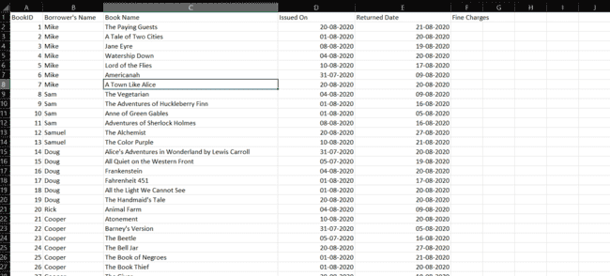

Fig 5.1 Library Data File (Input)

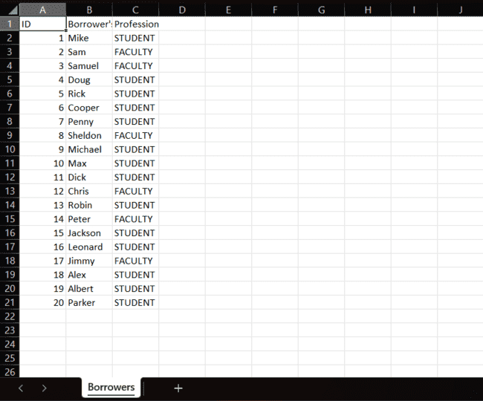

Fig 5.2 Borrowing Records (Input)

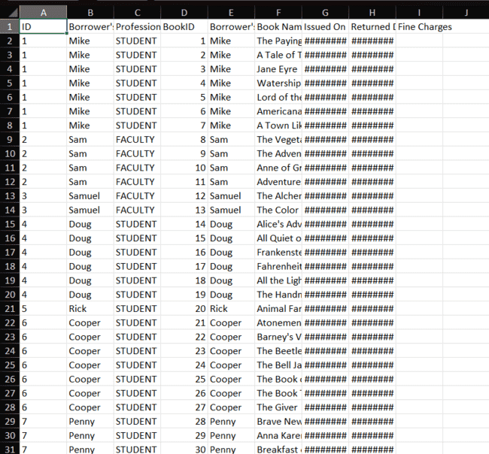

Fig 5.3 Reconciliation Debug (Output)

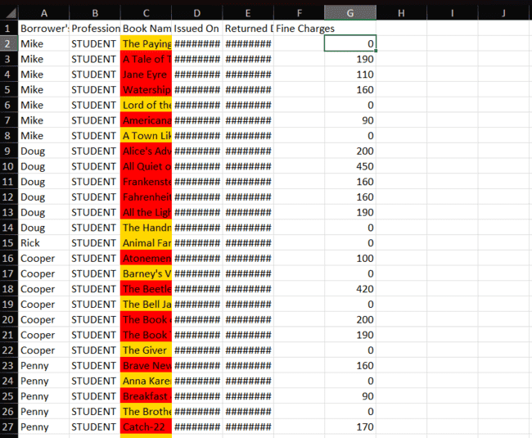

Fig 5.4 Updated Fine (Details)

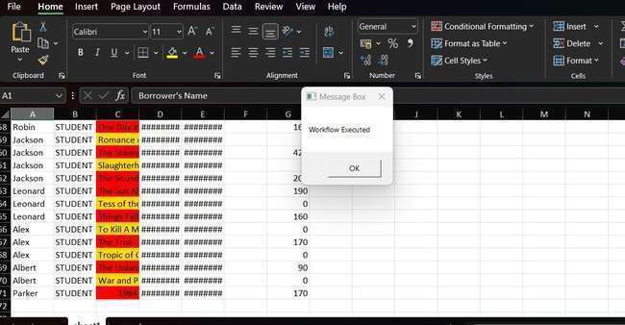

Fig 5.5 Workflow Execution Confirmation

**CHAPTER 6**

**CONCLUSION**

The Smart Borrower Automation Bot streamlines the process of managing lending institution resources, reconciling loan repayments or interest calculations, and notifying users. By leveraging UiPath RPA tools, the bot automates the retrieval of borrowing records, calculates loan repayments or interest calculations, organizes data into Excel files, and sends notifications via email. This reduces manual effort, saves time, and ensures accurate record management, enhancing the efficiency of lending institution operations.

The bot also incorporates robust error-handling and retry mechanisms, ensuring reliability even in case of data inconsistencies or process interruptions. By providing structured reports in Excel, it allows administrators to easily review and manage records, ensuring accurate and fair penalty reconciliation.

In conclusion, the Smart Borrower Automation Bot demonstrates the power of RPA to automate repetitive tasks, improve workflow efficiency, and enhance user experience. It offers a scalable and user-friendly solution for libraries, simplifying resource management and ensuring accurate and timely data processing.

**APPENDIX**

**SAMPLE PROCESS**

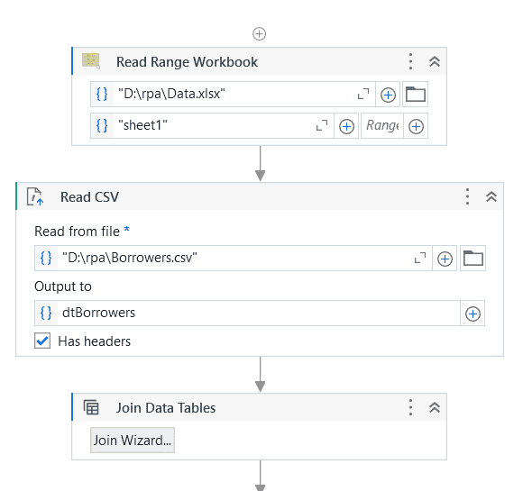

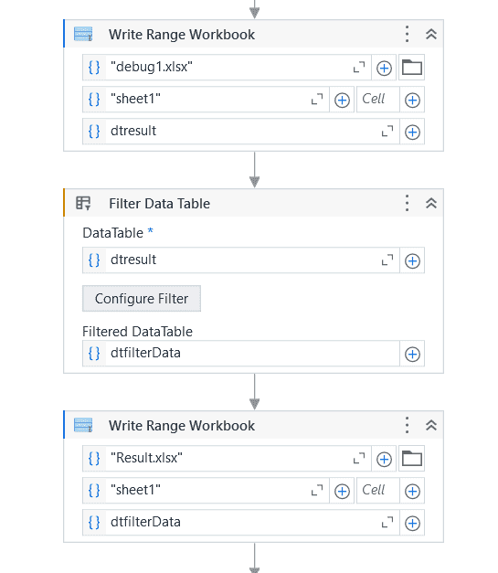

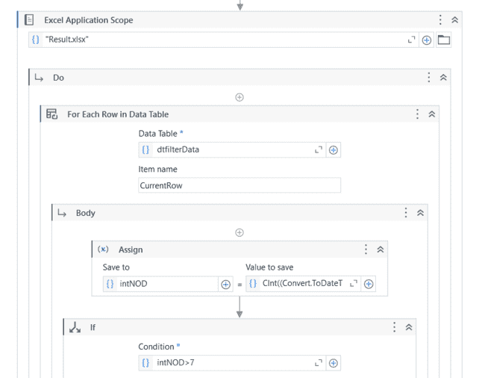

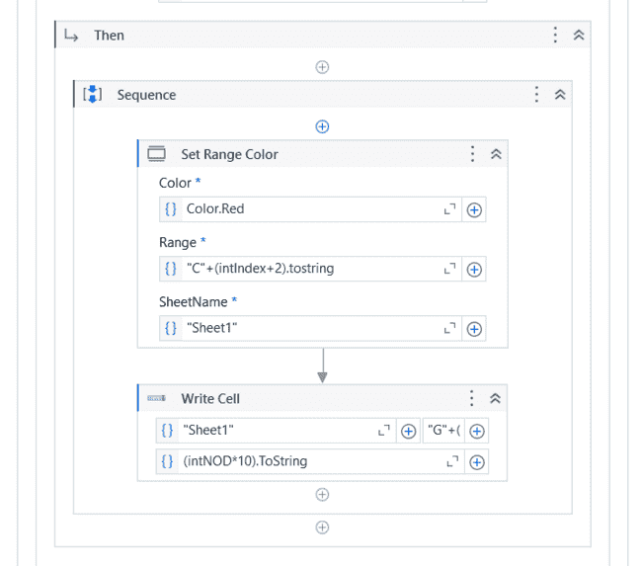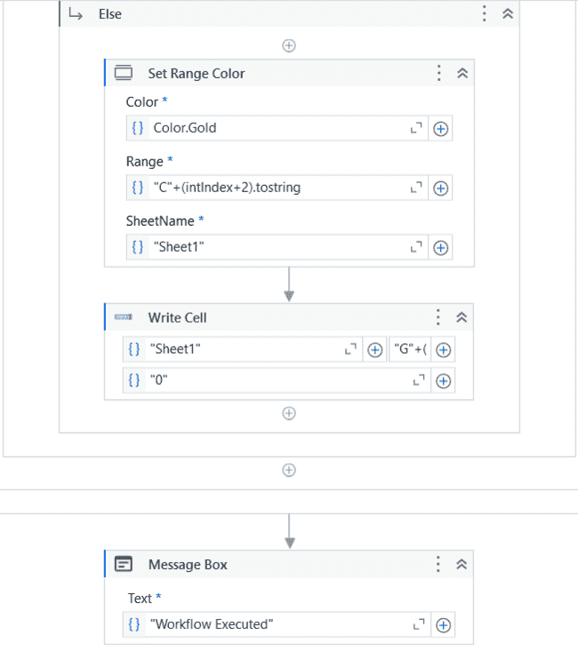

**REFERENCES**

1. UiPath Forum: The UiPath Forum community where users share their experiences and solutions. https://forum.uipath.com/
2. UiPath Documentation: The official documentation of UiPath features and functionalities https://docs.uipath.com/